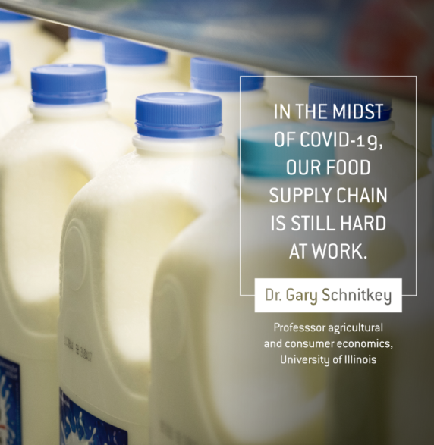

COVID-19 has significantly impacted our daily lifestyle, routines – even how we buy groceries. But even as we face ever-changing uncertainties, there’s one thing that COVID-19 doesn’t impact: food production.

Dr. Gary Schnitkey, professor of agricultural and consumer economics at the University of Illinois at Urbana-Champaign, explains:

- There is no danger of having food shortages due to lack of production. Production of perishable products like meat, milk and produce will continue, and it’s in our best interest to keep these systems producing.

- By necessity, the delivery of food within the supply chain will change. In meat plants, for example, product demand once geared toward restaurants will shift to fulfill grocery store needs, which may necessitate a change in final product and packaging.

- The empty shelves at grocery stores are not a reflection of halted food production. Rather, they are a reflection of a highly interconnected network of producers, distributors and retailers adjusting their supply to meet a surge in needs. Eggs, canned soup and everything in between will be replenished as the food supply chain adapts to this new normal.

Remember – food generally moves from rural to urban areas, involving transport across long distances. The good thing about our food system is that it can flex to our changing needs so we’re still able to enjoy safe, nutritious food for ourselves and our families.

